**MyCareer**

* **Description**

Up to 92% of people don’t get to achieve their career objective, that is due to many reasons, some of which are a very competitive job market, a decentralized education system and a lack of know-how. All of that combined together causes all of those people not to be able to achieve their goal. We are designing a platform that utilizes artificial intelligence to be able to scan profiles, resumes and CVs in order to help users get a list of skills that are necessary to achieve success in their career and match them with training centers that offer these trainings. By that, targeting students, young professionals and trainers.

* **Team members**
* **Mohamed Ahmed Mohamed Badrawy 21100872 (team leader)**
* **Mariam Khaled 21100814**
* **Haneen Ehab Mohamed Rady 21100792**
* **Ziad Mohamed Farouk 20200103**
* **Customer requirements**

1. Once the platform is opened via phone or website, a welcome page is previewed and the user is prompted to sign up or log in to an existing account

1.1. A user should be able to use log-in with Google or Facebook features for more ease of use.

1.2. When signing up the user should be prompted to complete his/her profile and upload an existing resume if it exists.

1.3. A user should be answering a list of questions about career interests, current career levels and other questions.

1.4 Upon successful sign up a user should have entered his/her email, address and phone number information.

2. A logged user should have accessibility to a range of options

2.1. Users should be able to navigate to resume builder section and information

about how it works.

2.2. Users should be able to access a wide variety of articles to gain knowledge

about the job market, most useful skills and other useful career advice articles.

2.3. Users should be able to view job opportunities available and customized for

his resume.

2.4. A user can contact a training center directly from our platform

3. Through our platform users can access a wide variety of courses offered by partners and can directly access the free ones offered.

3.1. Users shall view courses through a recommendation system for a

customized experience.

3.2. Paid options for accessing high quality content.

4. Our platform provides GPT-3 model integration that can generate a cover letter in seconds.

4.1. Users can edit the generated cover letter and give feedback about the output

5. The app will periodically send notifications containing recommendations and updates for the user to enhance his career.

5.1. The app should automatically progress the user skills and update the

courses recommendations.

5.2. The app will push a notification for users if a nearby event is happening that

may concern the user.

6. A user can go through an interview preparation process and interact with a chatbot that can advise him/her with upcoming steps

7. Training centers and employers can sign up for a commercial account.

8. Users can use two-factor authentication for more security added to their account.

8.1. A security key feature is added for extra security for commercial accounts

9. A user who wants premium features can use local payment methods such as Fawry, Vodafone cash etc.

9.1. When adding a payment method a verification is required through

withdrawing a 1 egp and returning them back to the user after verification is done

9.2. Information such as name, address, name on card is collected when adding

a payment method.

10. User applications to open job opportunities is saved in single tab that he/she

can access applications anytime.

10.1. Every application has attributes like applying date and status for

more clarity.

11. Users should be able to use and create cover letter and resume templates.

11.1. A user can choose to add his created template to public audience

after being reviewed by our team.

12. Identity verification is required for all commercial accounts created.

12.1 The app will ask for camera permission for easier verification

13. The app provides activity logs for more convenience.

14. A paid career counseling service is provided through our platform.

14.1. Users can communicate and connect with professionals directly after

Choosing to pay for the service.

15. Based on his/her feedback, a user can ask for a refund after using a paid service

* **Subsystems and functions**

Our platform will be consisting of:

* A: resume builder
* B: cover letter builder
* C: resume skills
* D: AI resume writer
* E: interview preparation
* F: training solutions
* G: job opportunities

Functionalities a user can use:

* H: Build a noticeably better resume.
* I: craft a well-formatted cover letter header and headline.
* J: Browse through a collection of skills customized to his/her resume
* K: Redirecting to partner websites specialized in advancing the skills through online courses
* L: AI-powered resume writer to generate an entire resume.
* M: Simulating realistic interviews for various job positions.
* N: A view of available training places to connect with.
* O: Online job search to find Jobs based on the data collected

Traceability matrix

|  |  |  |  |  |  |  |  |  |  |  |  |  |  |  |  |
| --- | --- | --- | --- | --- | --- | --- | --- | --- | --- | --- | --- | --- | --- | --- | --- |
|  | A | B | C | D | E | F | G | H | I | J | K | L | M | N | O |
| 1 | 0 | 0 | 0 | 0 | 0 | 0 | 0 | 0 | 0 | 0 | 0 | 0 | 0 | 0 | 0 |
| 2 | 1 | 0 | 1 | 0 | 1 | 0 | 0 | 0 | 0 | 0 | 0 | 0 | 0 | 0 | 0 |
| 3 | 0 | 0 | 0 | 0 | 0 | 0 | 0 | 0 | 0 | 1 | 1 | 0 | 0 | 0 | 0 |
| 4 | 0 | 0 | 0 | 0 | 0 | 0 | 0 | 0 | 1 | 0 | 0 | 0 | 0 | 0 | 0 |
| 5 | 0 | 0 | 0 | 0 | 0 | 1 | 0 | 0 | 0 | 0 | 0 | 0 | 0 | 1 | 0 |
| 6 | 0 | 0 | 0 | 0 | 0 | 0 | 0 | 0 | 0 | 0 | 0 | 0 | 1 | 0 | 0 |
| 7 | 0 | 0 | 0 | 0 | 0 | 0 | 0 | 0 | 0 | 0 | 0 | 0 | 0 | 0 | 0 |
| 8 | 0 | 0 | 0 | 0 | 0 | 0 | 0 | 0 | 0 | 0 | 0 | 0 | 0 | 0 | 0 |
| 9 | 0 | 0 | 0 | 0 | 0 | 0 | 0 | 0 | 0 | 0 | 1 | 0 | 0 | 0 | 0 |
| 10 | 0 | 0 | 0 | 0 | 0 | 0 | 1 | 0 | 0 | 0 | 0 | 0 | 0 | 0 | 1 |
| 11 | 1 | 1 | 0 | 1 | 0 | 0 | 0 | 0 | 0 | 0 | 0 | 0 | 0 | 0 | 0 |
| 12 | 0 | 0 | 0 | 0 | 0 | 0 | 0 | 1 | 0 | 0 | 0 | 0 | 0 | 0 | 0 |
| 13 | 0 | 0 | 0 | 0 | 0 | 0 | 0 | 0 | 1 | 0 | 0 | 0 | 0 | 0 | 0 |
| 14 | 0 | 0 | 0 | 0 | 0 | 0 | 1 | 0 | 0 | 0 | 0 | 0 | 1 | 0 | 1 |
| 15 | 0 | 0 | 0 | 0 | 0 | 0 | 0 | 0 | 0 | 0 | 0 | 0 | 0 | 0 | 0 |

* **Initial interfaces for identified subsystems**

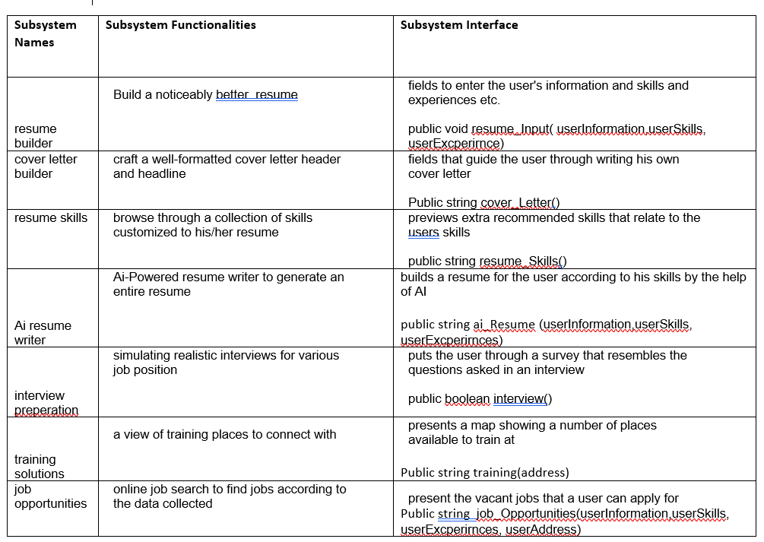

* **GUI**

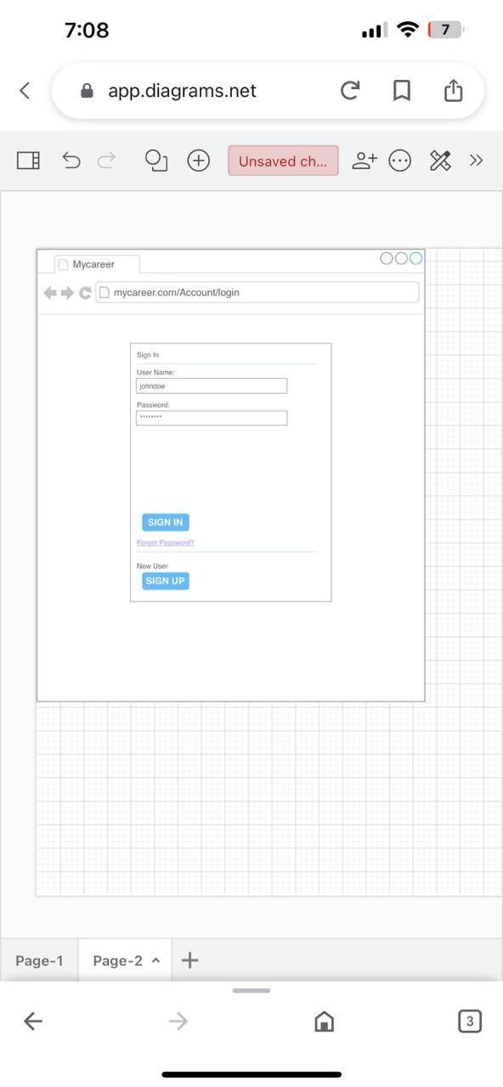

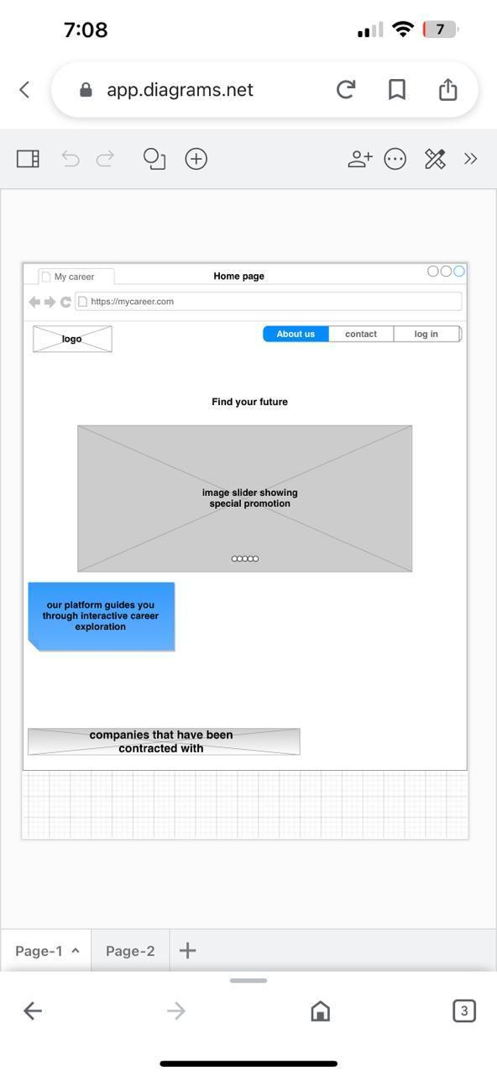

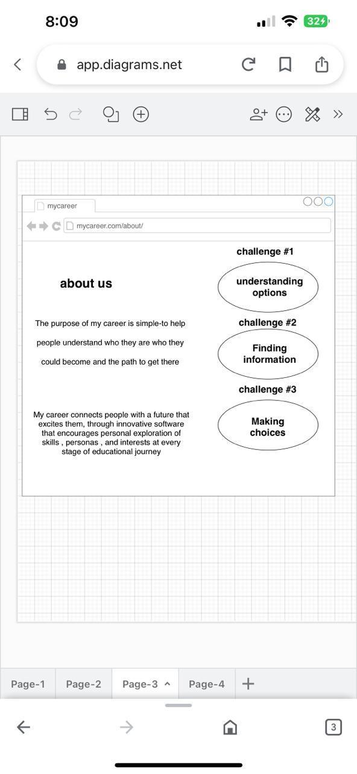

* **User manual**

1. The user shall type the url in the address bar or download the app from the store
2. The user should sign In using his username and password

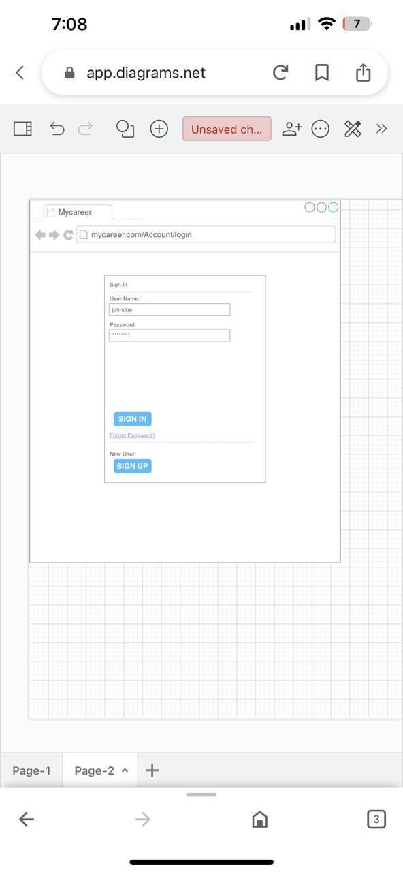

1. In the case of mobile application the user should give the app certain permissions such as Camera and SMS.
2. The user then should read and accept terms of use.
3. The user should be able to navigate through tabs or screens.

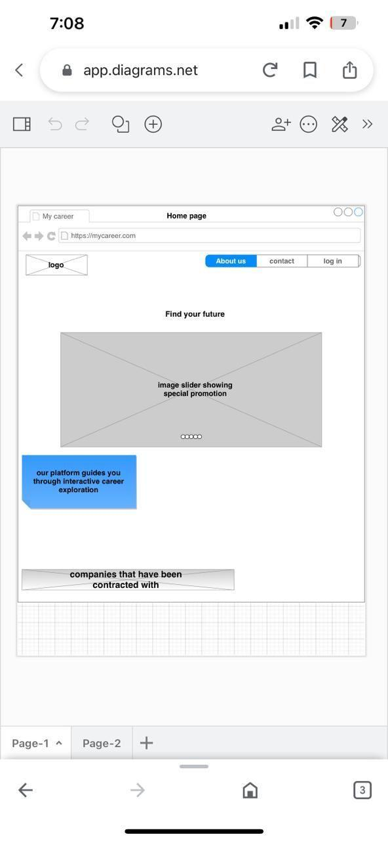

1. On of the tabs the user can access is the (about us Tab):

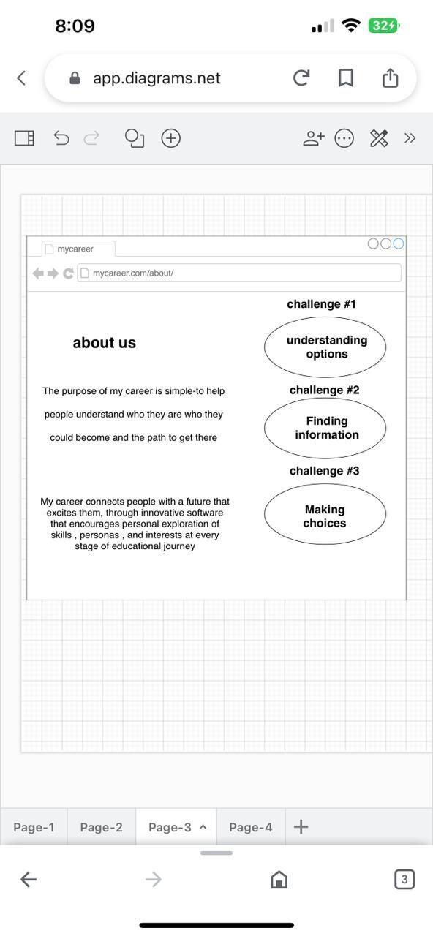

**Functional requirements:**

1. The platform should allow users to create and edit their resumes easily, with different templates and customization options.

1.1. Users should be able to enter their personal and professional information, work experience, education, skills, and other relevant details.

1. The platform should provide users with a feature to create and customize cover letters for job applications, with different templates and customization options.

2.1. Users should be able to enter information about the job they are applying for, their qualifications, and their motivation for applying.

1. The platform should provide users with a feature to list their skills and highlight their proficiency in each skill.

3.1. Users should be able to add or remove skills, and indicate their level of proficiency.

1. The platform should have an AI-powered feature that can analyze a user's resume and suggest improvements, such as highlighting keywords or restructuring content for better readability.
2. The platform should provide users with resources to help them prepare for job interviews.

5.1 Users should be able to access tips for answering common interview questions, advice on dressing appropriately, and other helpful guidance.

1. The platform should offer training courses and workshops to help users develop new skills or improve existing ones. This can include online courses, webinars, or other forms of training.
2. The platform should connect users with job opportunities that match their skills and experience. This can include job listings from various sources, personalized job recommendations, or even direct connections with potential employers.
3. The platform should allow users to customize their resumes to fit specific job descriptions or industries, by providing relevant keywords or suggestions for changes.
4. The platform should allow users to customize their cover letters to fit specific job descriptions or companies, by providing relevant information or suggestions for changes.
5. The platform should allow users to share their resumes with potential employers or recruiters, by providing a shareable link or sending the resume directly through the platform.
6. The platform should use algorithms to match job seekers with relevant job opportunities based on their skills, experience, and preferences.
7. The platform should allow users to track the status of their job applications, by providing notifications or updates on whether their application has been received, reviewed, or rejected.

**Non-functional requirements:**

1. The platform should be easy to use and navigate, with clear instructions and intuitive design.
2. The platform should be fast and reliable, with minimal downtime.
3. The platform should be secure, with user data encrypted and protected from unauthorized access.
4. The platform should be able to handle a large number of users and job postings without experiencing performance issues.
5. The platform should be compatible with a variety of devices and browsers, so that users can access it from any device they choose.
6. The platform should provide users with access to customer support, so that they can get help with any issues or questions they may have.
7. The platform should be designed to be accessible to users with disabilities, complying with relevant accessibility standards.
8. The platform should support multiple languages to cater to users from different regions.
9. The platform should be dependable, ensuring that it can perform its intended function correctly and consistently.
10. The platform should be available to users at all times, with minimal downtime or maintenance.
11. The platform should respond promptly to user requests, ensuring that users can complete their tasks efficiently.
12. The platform should protect the privacy of users' personal information and ensure that it is not misused or shared without their consent.
13. The platform should perform well, ensuring that it can handle heavy traffic and provide a seamless user experience.
14. The platform should provide a positive user experience, with intuitive navigation, clear messaging, and engaging visuals.
15. The platform should be easy to maintain and update, allowing for quick fixes and improvements

**Use case diagram**

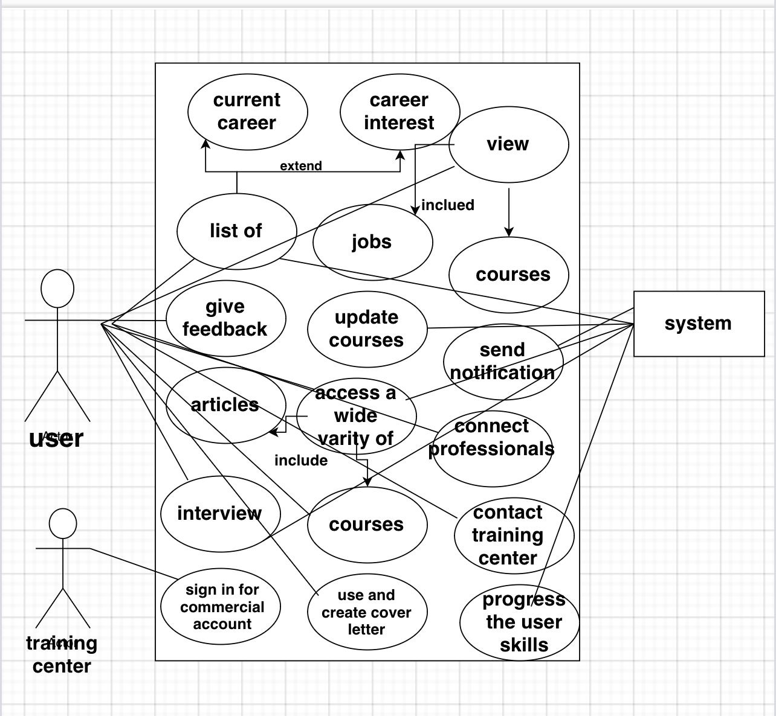

**System services:**

1. Authentication and Authorization Service: This service would handle user authentication and authorization, by verifying user credentials and granting appropriate access permissions to various platform features.
2. Resume Building Service: This service would generate customized resumes for users, by allowing them to select from pre-built templates, or by creating their own template from scratch, and providing suggestions for formatting and content based on user input.
3. Cover Letter Building Service: This service would generate customized cover letters for users, by allowing them to select from pre-built templates, or by creating their own letter from scratch, and providing suggestions for content based on user input.
4. Skill Analysis Service: This service would analyze user skills, based on their resume and other input, and provide suggestions for improving or highlighting skills based on employer demand.
5. AI Resume Writing Service: This service would use AI algorithms to analyze user resumes and generate suggestions for improvement, such as highlighting skills or formatting changes.
6. Interview Preparation Service: This service would provide resources to help users prepare for job interviews, including sample interview questions and answers, tips on how to dress and behave during an interview, and mock interviews.
7. Training Solution Service: This service would provide users with access to training courses and resources that can help them improve their job skills or learn new ones.
8. Job Matching Service: This service would match job seekers with relevant job opportunities based on their skills, experience, and preferences.
9. Job Application Service: This service would allow users to apply for jobs directly through the platform, by submitting their resume and cover letter to potential employers.
10. Job Alert Service: This service would send users alerts when new job opportunities are posted that match their preferences, based on their resume and other input.
11. Reporting Service: This service would generate reports on user activity and platform usage, providing insights into how users are engaging with the platform and where improvements could be made.
12. Notification Service: This service would send notifications to users regarding their job applications, interview invitations, and other important events related to their job search.

**System rules:**

* **Must have rules:**

1. System should have a requirement for users to create an account in order to access the platform's features.
2. System should have a requirement for users to provide accurate and truthful information when creating their resumes, cover letters, and profiles.
3. System should have a restriction on sharing or distributing any content from the platform that users do not have permission to share.
4. System should have a prohibition on behavior that could be considered discriminatory, harassing, or offensive towards other users or potential employers.
5. System should have a policy that the platform will not sell or share user data with third parties without explicit user consent, except in cases where it is required by law.
6. System should have a requirement for users to abide by the terms and conditions of the platform, including any rules or policies regarding prohibited behavior.
7. System should have the right to suspend or terminate user accounts that violate the terms and conditions or engage in prohibited behavior.
8. System should not guarantee that users will find employment through the platform, but will provide resources and tools to help users improve their chances of finding a job.
9. System should prohibit any activity that could harm or disrupt the platform's infrastructure, including attempting to access or modify system files or data.
10. System should provide support to users who experience technical difficulties or issues with platform features, but cannot guarantee that all issues will be resolved immediately.
11. System should regularly update and improve platform features and functionality, based on user feedback and industry trends.
12. System should comply with all relevant laws and regulations related to job search and hiring practices, including equal employment opportunity laws and anti-discrimination laws.

-**Shall not have rules:**

1. System should not have access to user data or personal information without explicit user consent.
2. System should not have any hidden fees or charges associated with using the platform's features.
3. System should not have any bias towards or against specific users or groups based on demographic factors.
4. System should not have any restrictions on users' ability to delete or modify their own content and data.
5. System should not have any security vulnerabilities or weaknesses that could be exploited by malicious actors.
6. System should not have any policy or practice that violates user privacy or data protection laws.
7. System should not have any limitation on users' ability to connect with potential employers or apply for jobs through the platform.
8. System should not have any policy or practice that discriminates against users based on their employment history, education, or other factors.
9. System should not have any policy or practice that restricts users' ability to express themselves or share their opinions on the platform.
10. System should not have any hidden algorithms or automated decision-making processes that unfairly advantage or disadvantage certain users.

**Use cases:**

**Use case 1:** Career starters

**Actors:** Recent graduates or individuals who have completed vocational or technical training programs.

**Description**: The system could be used by job seekers who are just starting their careers, by providing them with resume and cover letter builders, resume skills, and AI resume writer. It could help them create an impressive resume and cover letter that highlights their strengths and skills, and increase their chances of getting a job.

**Typical course of events:**

|  |  |
| --- | --- |
| **Actors intentions**  1- User enters (log in) to the system  5- User views the services provided by our platform through its assigned tab  7- User presses “resume builder“  10- User selects whether he/she has a resume to improve or he/she wants to build resume and enter existing experience and skills | **System responsibilities**  2- System gets the entered user information  3- System validates that such user exists  4- System opens the dashboard page  6- System opens a list view of the services  8- The system shows a description of how this service work and how to best use it  9- The system shows a brief description of what an outstanding resume shall look like and how to improve it using our platform  11- The system starts the process of building the resume and produces the required output to the user |

**Alternative courses**

* Step 1: Error while logging in. The system provides an error message if the user credentials entered were incorrect and asks him to sign up if the email does not exist.
* Step 7: User has the privilege to use premium features so he/she clicks to use a more enhanced version of the service “Resume builder”.

**Use case 2:** College students

**Actors:** Students enrolled in a university degree or equivalent

**Description:** College students could use the system to create resumes and cover letters for internships and job applications. The system could also provide them with training solutions to enhance their skills and prepare them for the job market.

**Typical course of events:**

|  |  |
| --- | --- |
| **Actors intentions**  1- A college student logs in to the system  5- College student opens his/her profile by clicking on the profile icon in the header of the website or tab bar in mobile application  7- College student clicks on “update my information”  9- College student inputs his/her password  10- College student starts to update his information to include his /her university, university location, field of study, .edu email if exists and the expected graduation date  11- College student clicks on save button  13- College student goes to home page and selects “build a customized resume”  16- College student gives feedback  18- College students view statistics about the places he views and selects one to apply to | **System responsibilities**  2- System gets the entered user information  3- system validates that such user exists  4- System opens dashboard page  6- System opens user profile  8- System prompt the user to enter his password for extra verification  12-System saves the information provided  14-System starts building a resume based on the information it has and outputs the resume to the user.  15- System waits for the user to view and give feedback for the output.  17- System redirects the user to the internships section and recommend some places that he can apply to |

**Alternative courses**

* Step 1.a : There’s no internet connection. When a user's phone doesn’t have an internet connection, the application will warn the user by showing the message “Please check your internet connection.”
* Step 1.b : Failure to verify the account of the member, either because of a non-registered member or entering wrong user information.
* Step 9 : Wrong password for the extra verification, the system prompts the user to try again or reset his/her password.
* Step 10: If the student does not have an edu email the process fails and the user is redirected to the dashboard

**Use case 3:** Interview Preparation

**Actors:** Recent graduates or individuals who have completed and system

**Description**: The system could help job seekers prepare for interviews by providing them with interview preparation materials such as commonly asked questions, tips on how to answer them, and personalized feedback on their performance..

**Typical course of events:**

|  |  |
| --- | --- |
| **Actors intentions**  1- User enters (log in) to the system  5- User views the services provided by our platform through its assigned tab  7- User presses “Interview Preparation “  10 -The user answered the questions of the survey  13-The user answered the questions of the survey | **System responsibilities**  2- System gets the entered user information  3- System validates that such user exists  4- System opens the dashboard page  6- System opens a list view of the services  8- System prompt the user to enter his password for extra verification  9- the system displays a collection of interview related questions  11- System checks and analyses the user answers  12-System displays the results to the user in addition to where the went wrong and how the can improve  14-System processes the user entries. |

**Alternative courses**

* Step 1: Error while logging in. The system provides an error message if the user credentials entered were incorrect and asks him to sign up if the email does not exist.
* Step 2 : There’s no internet connection. When a user's phone doesn’t have an internet connection, the application will warn the user by showing the message “Please check your internet connection.”
* Step 3 : the user can’t leave an entry on answer

**Use case 4:** Career Coaches

**Actors:** coaches who help people to find and improve their career

**Description**: Career coaches could use the system to provide their clients with tools to help them create professional resumes, cover letters, and online profiles. They could also use the system to assess their client's skills and provide training solutions to improve them.

**Typical course of events:**

|  |  |
| --- | --- |
| **Actors intentions**  1.a career coach log in to the system  5.user View clients information  7.User Assess the clients cv’s | **System responsibilities**  2. System gets the entered user information  3- system validates that such user exists  4- System opens dashboard page  6. Displays clients information |

**Alternative courses**

* Step 1: Error while logging in. The system provides an error message if the user credentials entered were incorrect and asks him to sign up if the email does not exist.
* Step 2: Failure to verify the account of the member, either because of a non-registered member or entering wrong user information.

**Test Requirements:**

1. Welcome Page and User Sign Up/Log In   
  
• Verify that the welcome page is displayed correctly on both the phone and web versions.   
  
• Test the functionality of the "log in with Google or Facebook" feature, ensuring that users can successfully log in using these options.   
  
• Verify that the user is prompted to complete their profile and upload a resume when signing up for a new account.   
  
• Ensure that users are able to answer the list of questions about their career interests and levels.   
  
• Verify that users are able to enter their email, address, and phone number information upon successful sign-up.   
  
2.User Accessibility Options   
  
• Test the resume builder section and ensure that it is functional and informative.   
  
• Verify that users can access a wide variety of articles about the job market, useful skills, and career advice.   
  
• Ensure that job opportunities are customized based on the user's resume and are displayed correctly.   
  
• Verify that users can contact a training center directly from the platform.

3.Course Access   
  
• Test the recommendation system for customized course access and ensure that it is working correctly.   
  
• Verify that users can access free courses and paid options for high-quality content.   
  
4.GPT-3 Model Integration for Cover Letter Generation   
  
• Test the cover letter generation feature and ensure that it is functioning correctly.   
  
• Verify that users can edit the generated cover letter and provide feedback about the output.  
5.Notifications and Recommendations   
  
• Ensure that notifications are being sent periodically to users and that they contain relevant recommendations and updates.   
  
• Verify that the app is automatically progressing the user's skills and updating course recommendations.   
  
• Ensure that users receive a notification if a nearby event is happening that may concern them.   
  
6.Interview Preparation Process and Chatbot Interaction   
  
• Test the interview preparation process and interaction with the chatbot and ensure that they are functional and informative.   
  
7.Commercial Accounts for Training Centers and Employers   
  
• Verify that training centers and employers can successfully sign up for commercial accounts.   
  
8.Two-Factor Authentication and Security   
  
• Test the two-factor authentication feature and ensure that it is working correctly.   
  
• Verify that the security key feature is added for extra security for commercial accounts.   
  
9.Payment Methods for Premium Features   
  
• Test the local payment methods such as Fawry and Vodafone cash and ensure that they are working correctly.   
  
• Verify that users are required to verify their payment method by withdrawing and returning 1 EGP before adding it to their account.   
  
• Ensure that user information such as name, address, and name on card is collected when adding a payment method   
  
10.User Applications and Attributes   
  
• Verify that user applications to open job opportunities are saved in a single tab that they can access anytime.   
  
• Ensure that every application has attributes like applying date and status for more clarity.  
11.Cover Letter and Resume Templates   
  
• Test the functionality of creating and using cover letter and resume templates.   
  
• Verify that users can choose to add their created templates to the public audience after being reviewed by the team.   
  
12.Identity Verification for Commercial Accounts   
  
• Test the camera permission feature for identity verification and ensure that it is working correctly.  
13.Activity Logs   
  
• Ensure that the app provides activity logs for more convenience.   
  
14.Paid Career Counseling Service   
  
• Verify that users can communicate and connect with professionals directly after choosing to pay for the service.   
  
15.Refund Request for Paid Services   
  
• Test the functionality of refund requests for paid services and ensure that users can ask for a refund based on their feedback.